3 Thumbz Up LLC Community Garden
“Growing Through Nature”
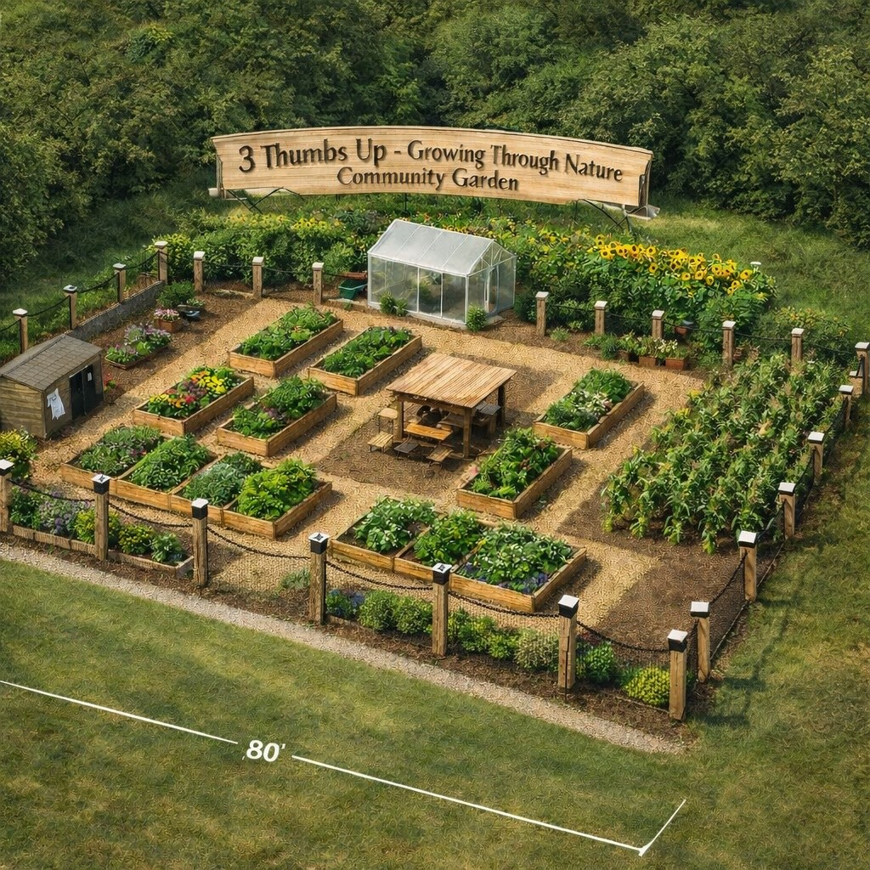

Project Overview
3 Thumbz Up LLC is developing a community garden designed to bring veterans, families, and local residents together through agriculture, wellness, and education. The garden will provide a space where individuals can learn to grow their own food, build community connections, and participate in therapeutic outdoor activities.

Mission
Our mission is to strengthen the community by providing a welcoming environment where people can grow food, build relationships, and improve mental and physical wellness through nature.

Startup Cost
The estimated startup cost for the initial phase of the 3 Thumbz Up Community Garden is approximately $6,000. Funding will support raised beds, soil, fencing, greenhouse materials, irrigation supplies, signage, and community seating areas.

Sponsorship Opportunities

Platinum Sponsor – $2,000+
• Large logo on garden entrance sign
• Recognition on all promotional materials
• Featured recognition at community events
• Dedicated garden bed named after sponsor

Gold Sponsor – $1,000
• Medium logo displayed at garden
• Recognition on website and social media
• Sponsor name on a raised garden bed

Silver Sponsor – $750
• Name listed on community sponsor board
• Recognition on social media

Sponsor a Cistern – $500
Sponsors can fund a rainwater collection cistern that will be used to sustainably water the garden. Sponsors will have their name displayed on the cistern they support.

Community Supporter – $100
Community members and small businesses can contribute to the project and will be recognized on the supporter board within the garden.

Get Involved
3 Thumbz Up LLC welcomes partnerships with local businesses, organizations, and individuals who believe in strengthening our community through nature. Together we can create a space that promotes health, education, and connection.

